**CSP 586 project output**

**Team 20 :**

Bin Sun A20376746

Xiaofei Xie A20406972

Peng Guo

1 Use the bracket to open the HTML file

2 Main page displayed in google chrome

3 Select the dataset from the main page

4 Select the dataset from the main page or from local file

5 Select the columns

6 Selected by rows

7 statistic datasets

8 Plot the dataset in bar chart

9 Plot the dataset in line chart

10 Plot the dataset in pie chart

11 Plot the dataset in doughnut chart

12 Plot the dataset in stacked bar chart

13. Plot the dataset in Heat Map

Use the bracket to open the HTML file

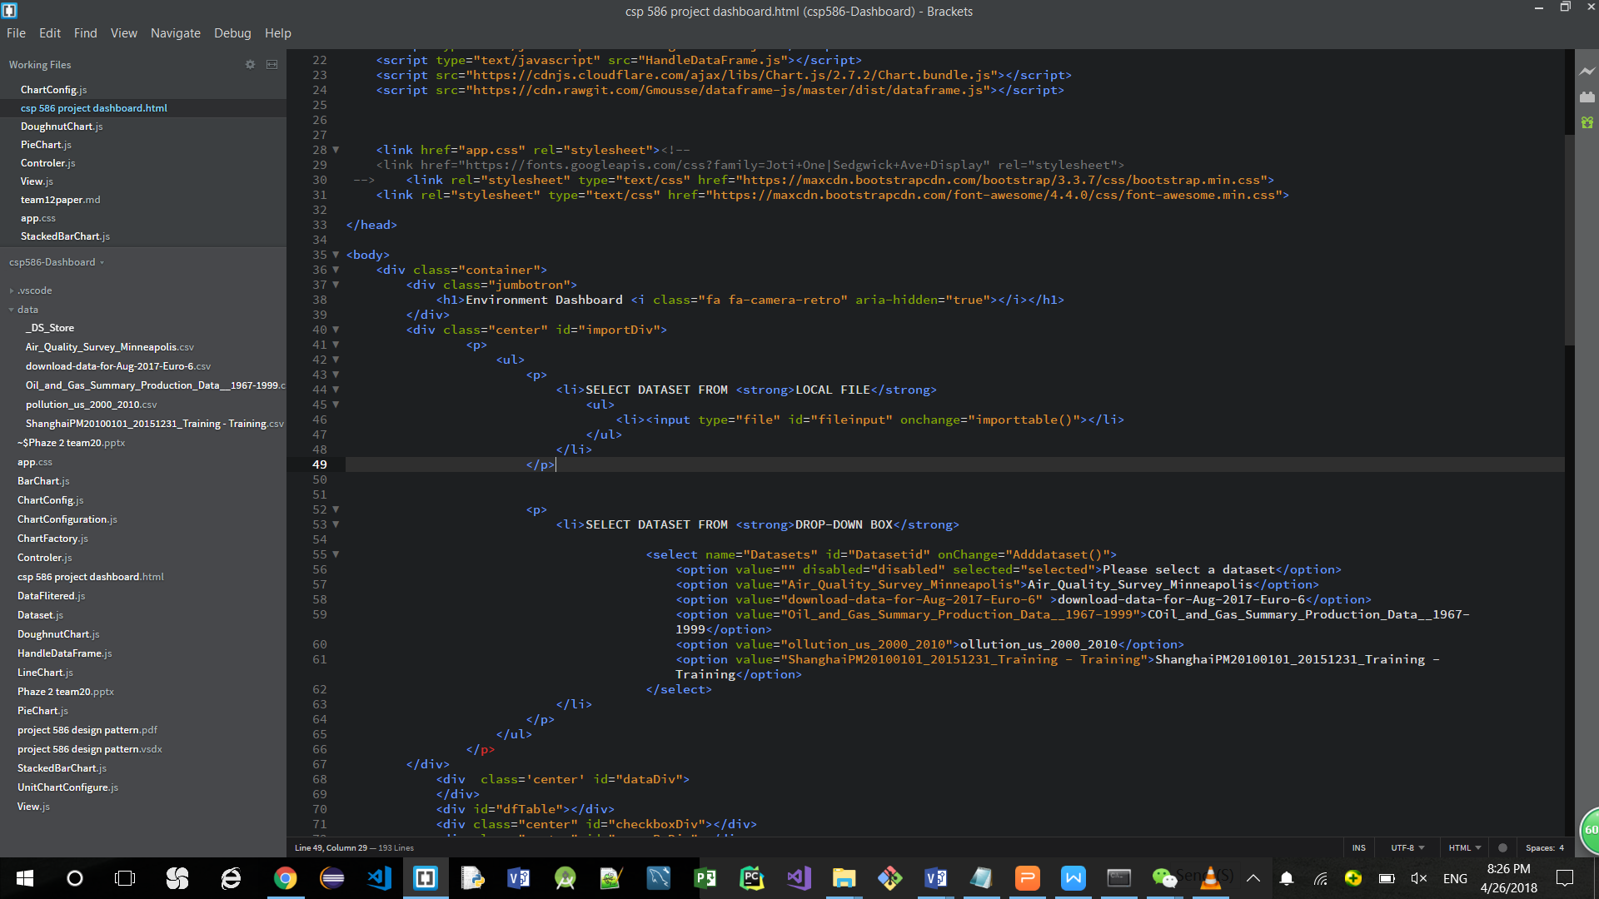

Main page displayed in google chrome

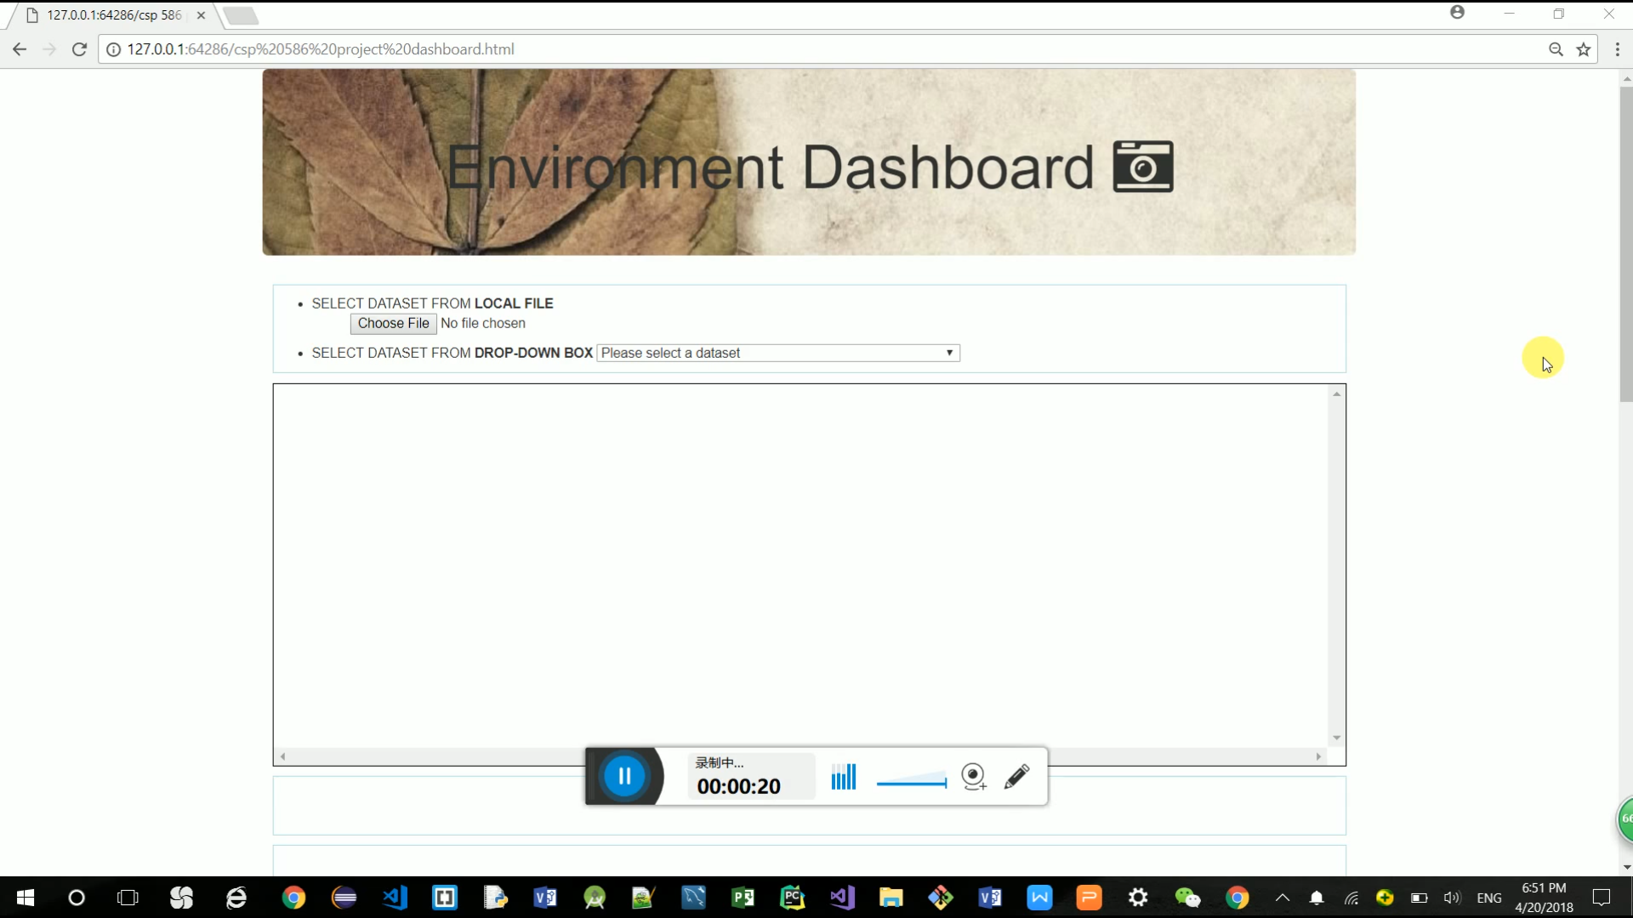

Select the dataset from the main page

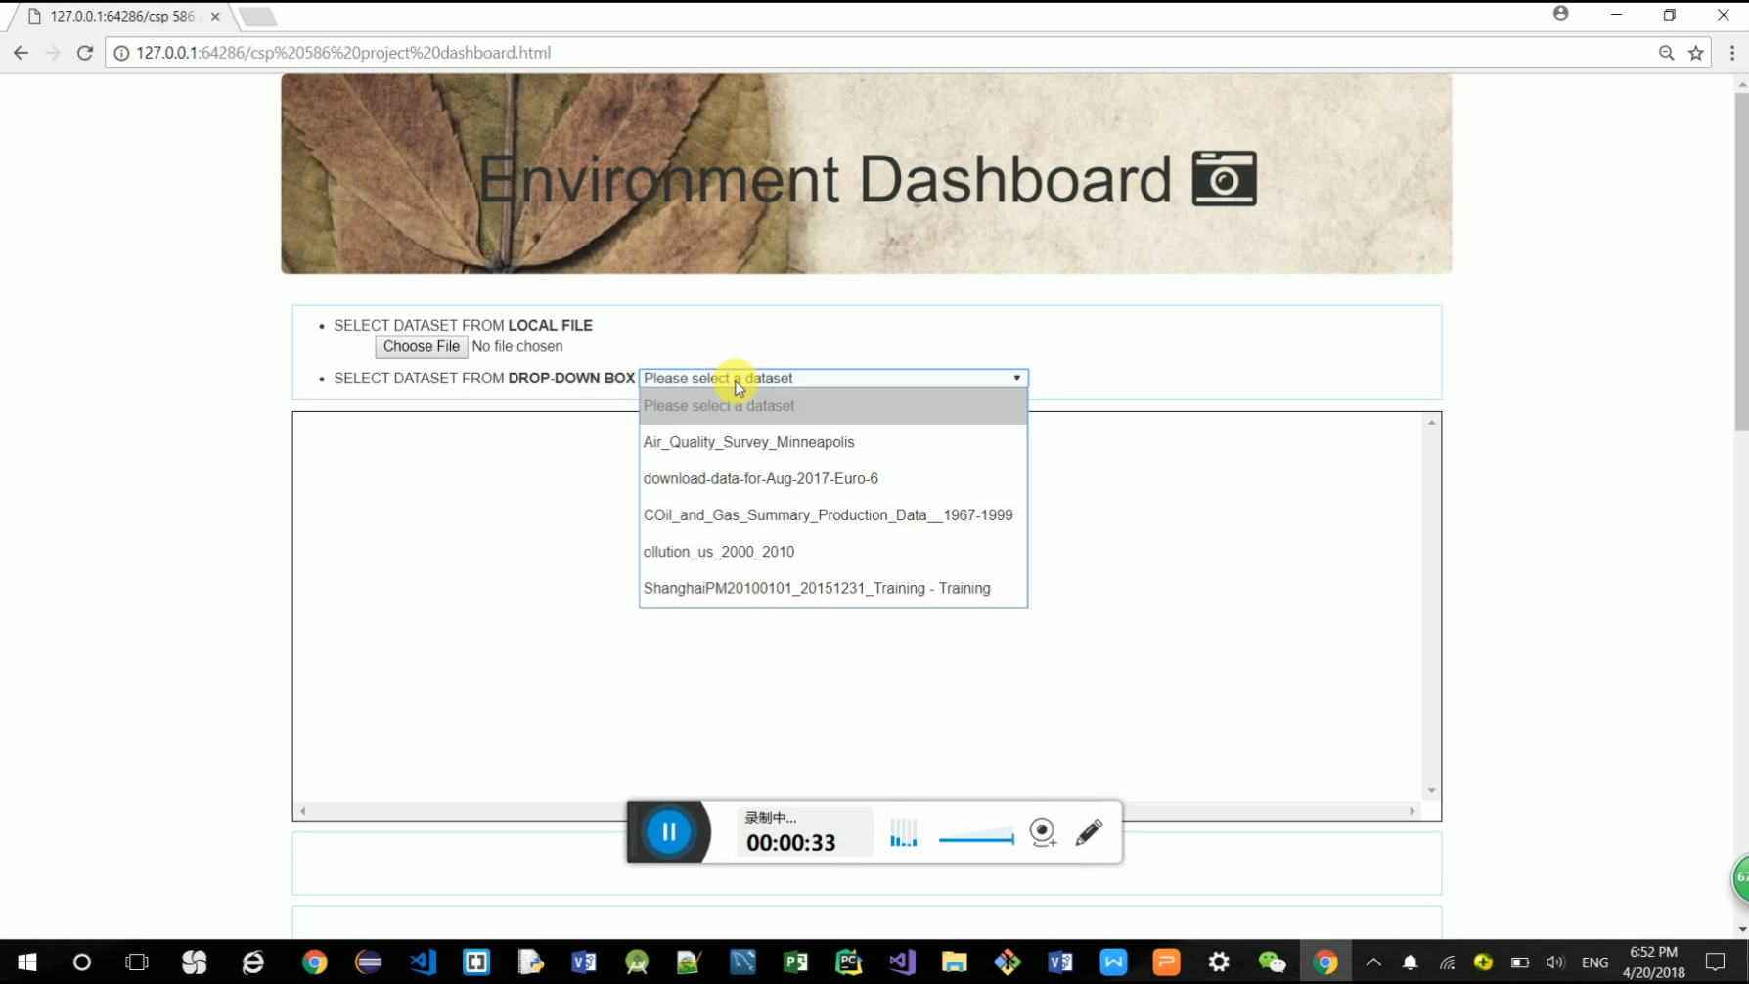

Select the dataset from the local file

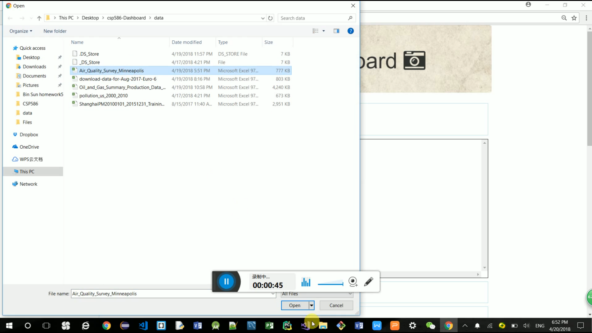

Dataset is imported and displayed

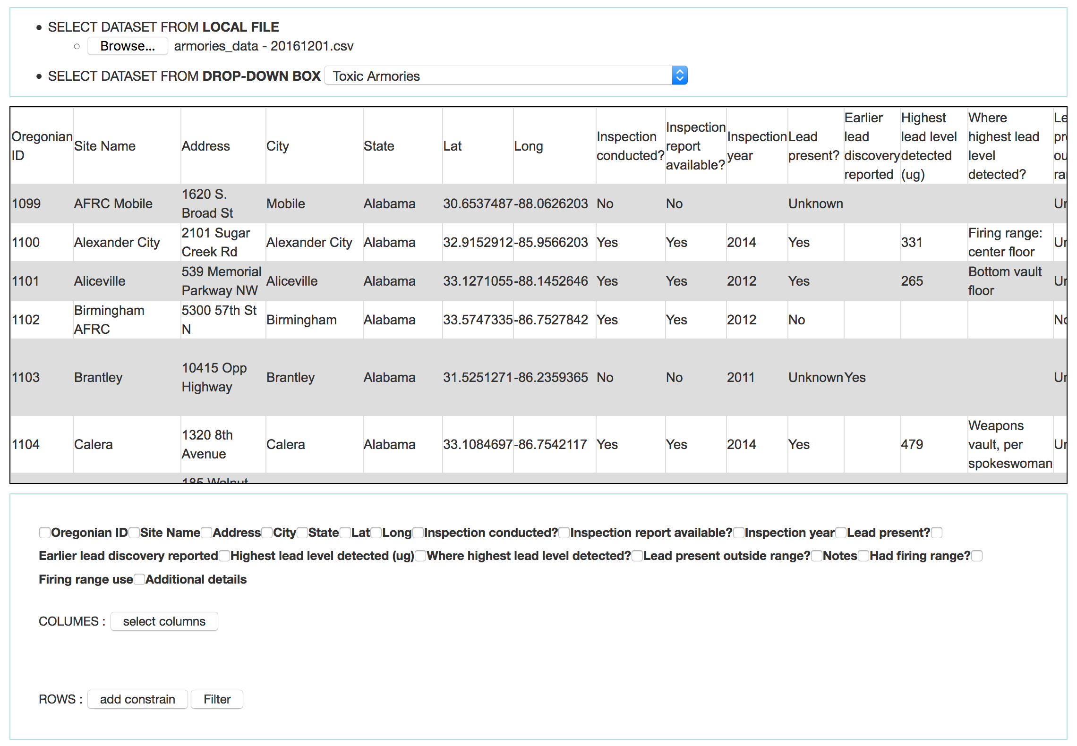

Select the columns

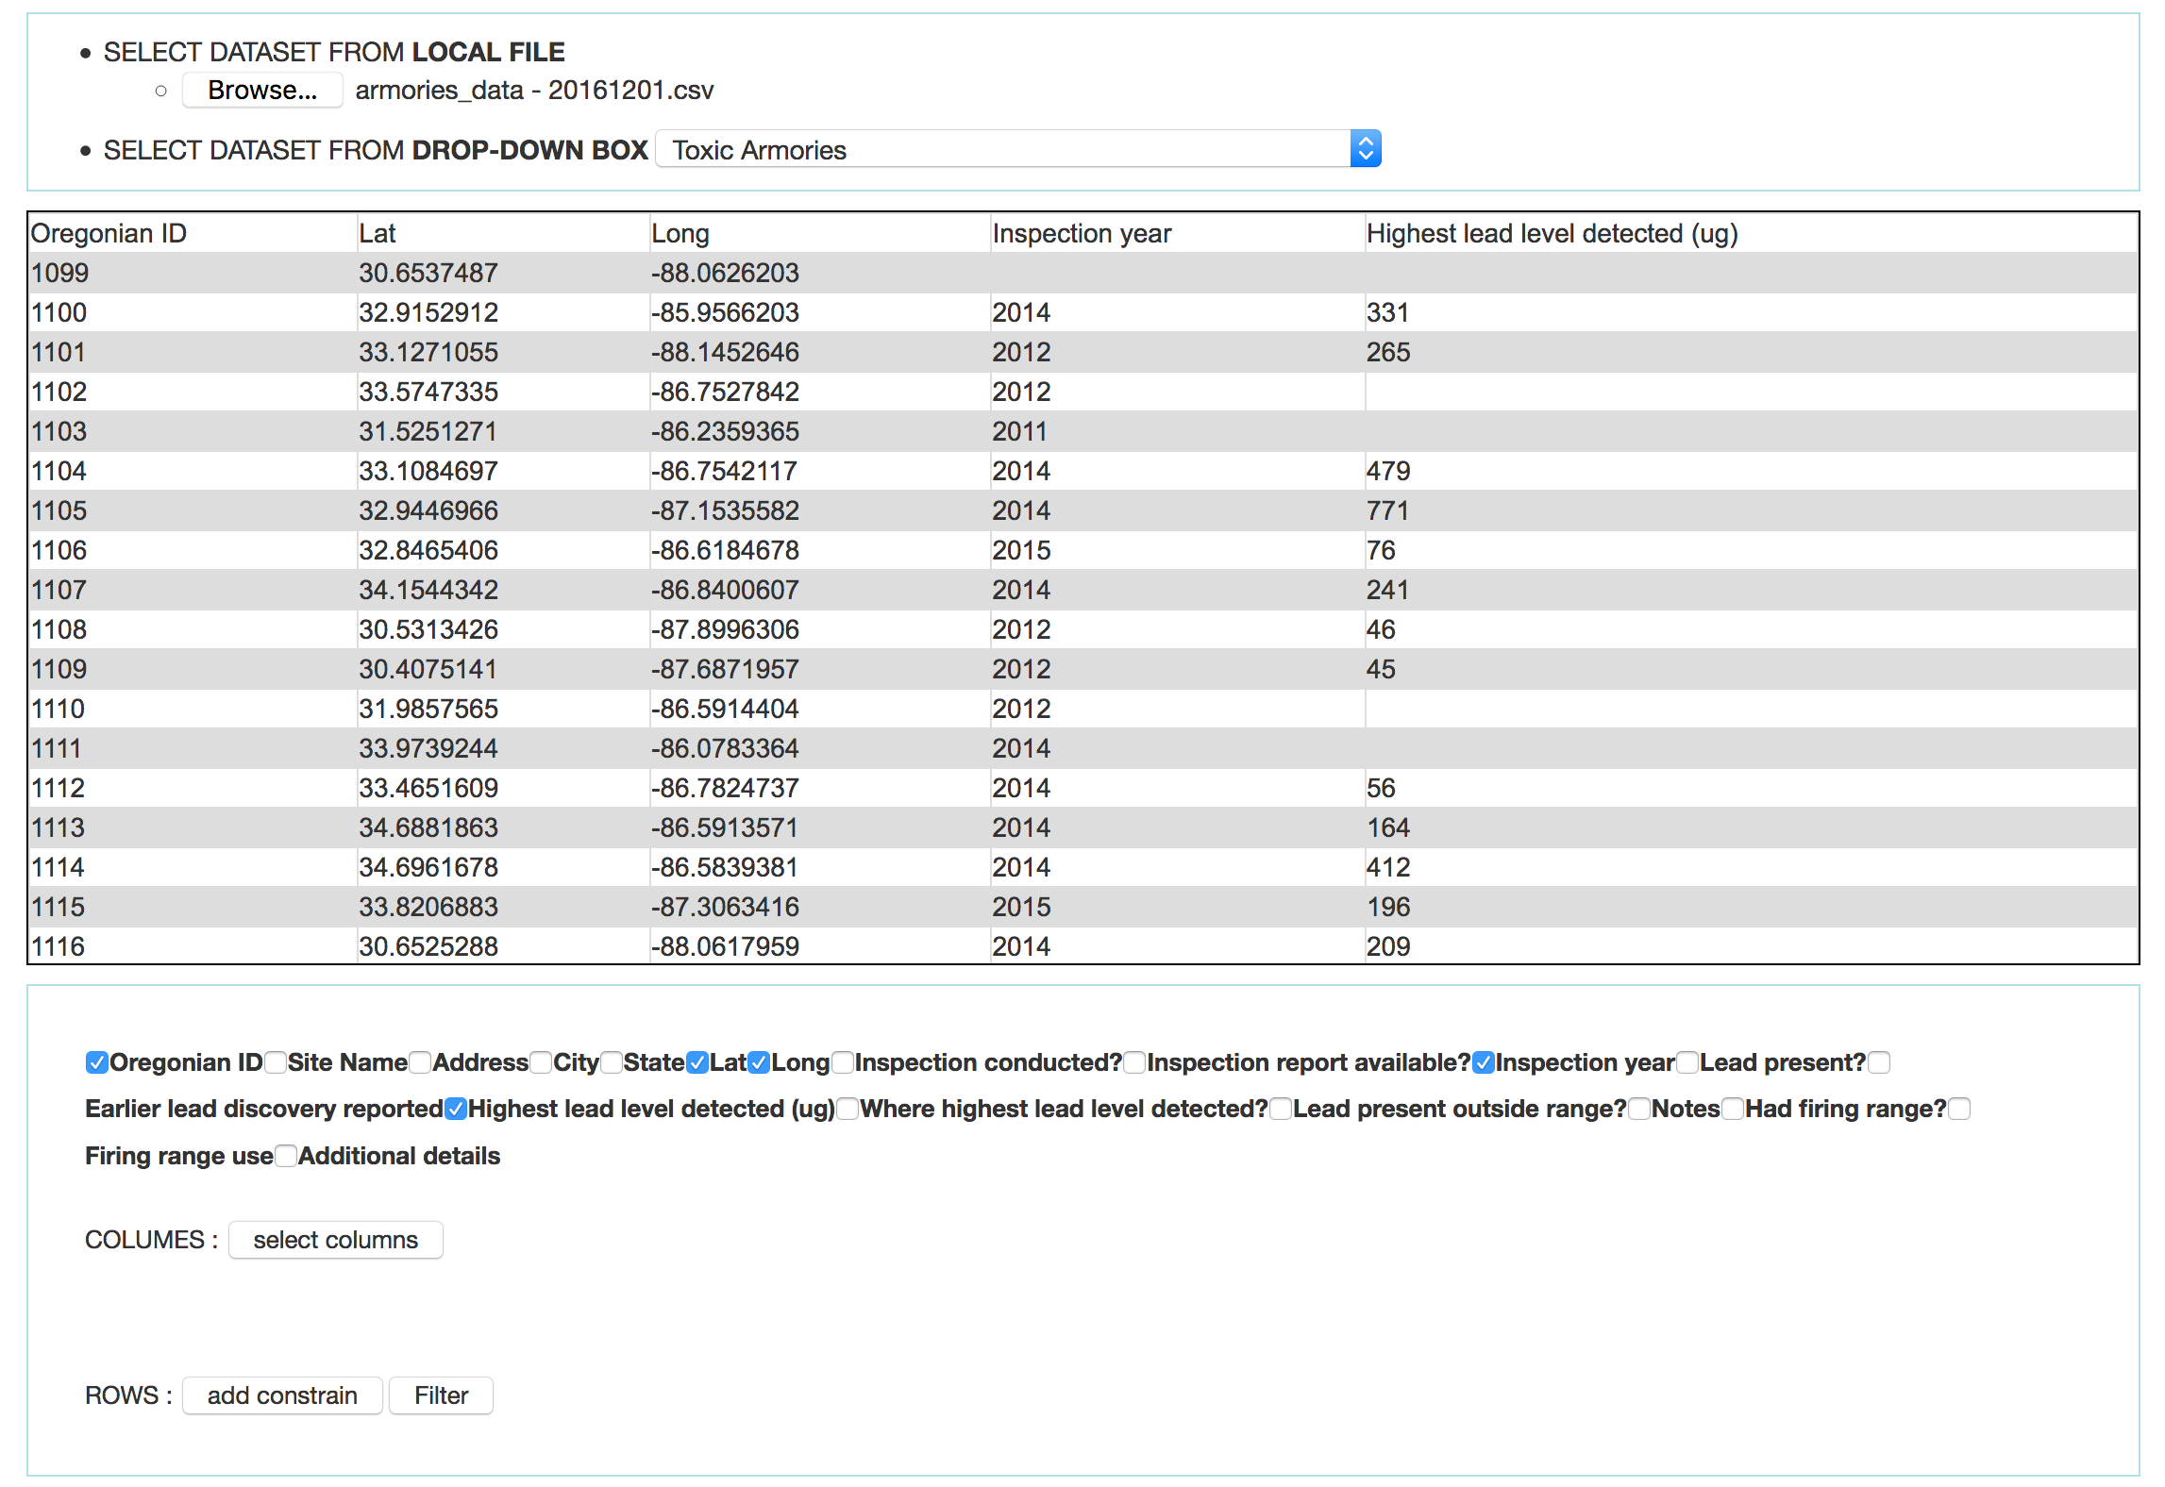

Selected by rows

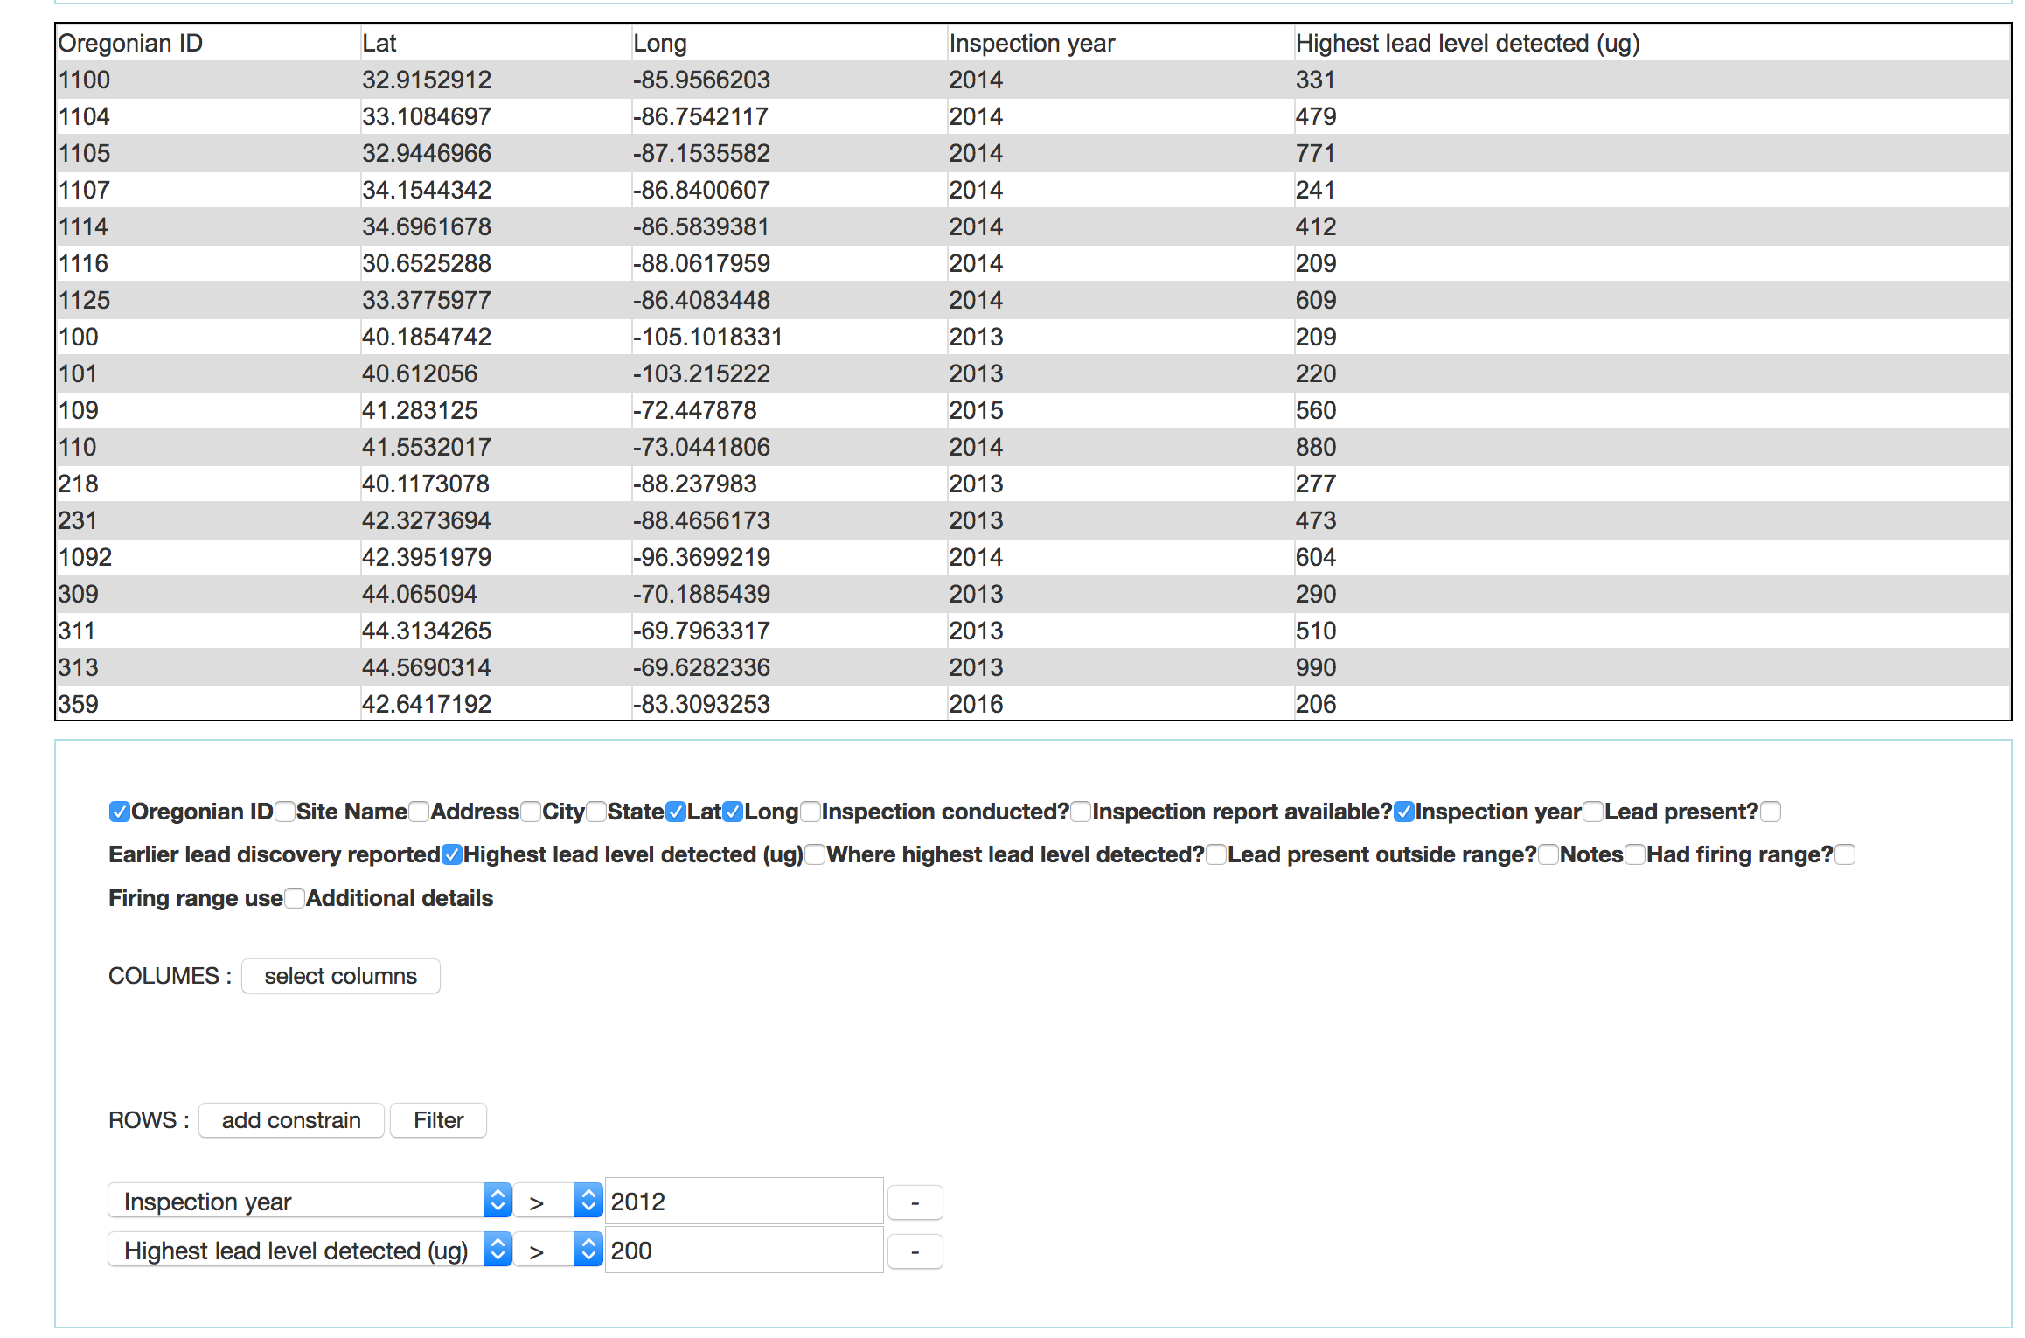

Statistic datasets

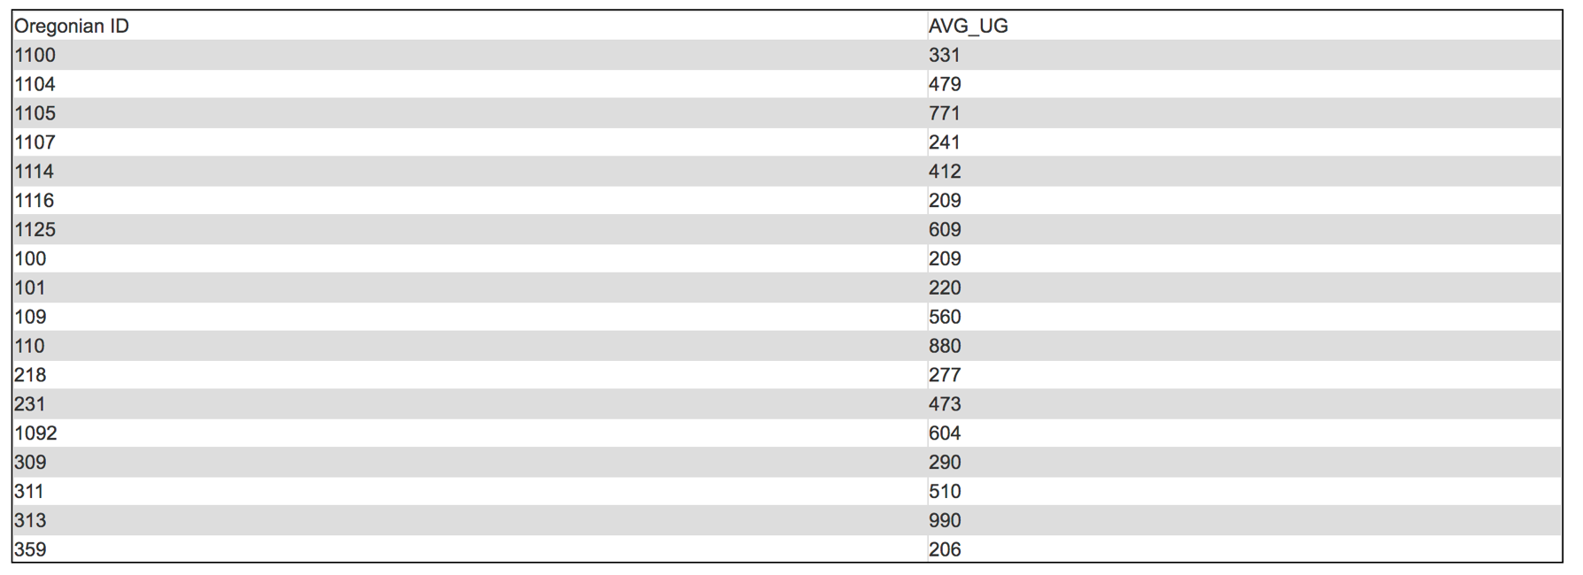

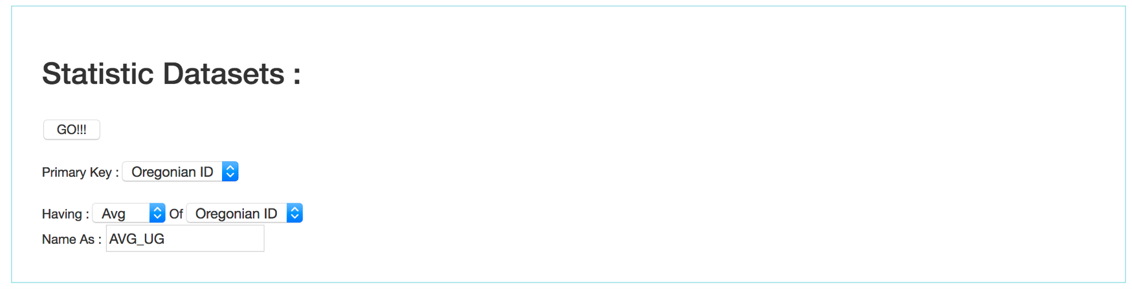

Plot the dataset in bar chart

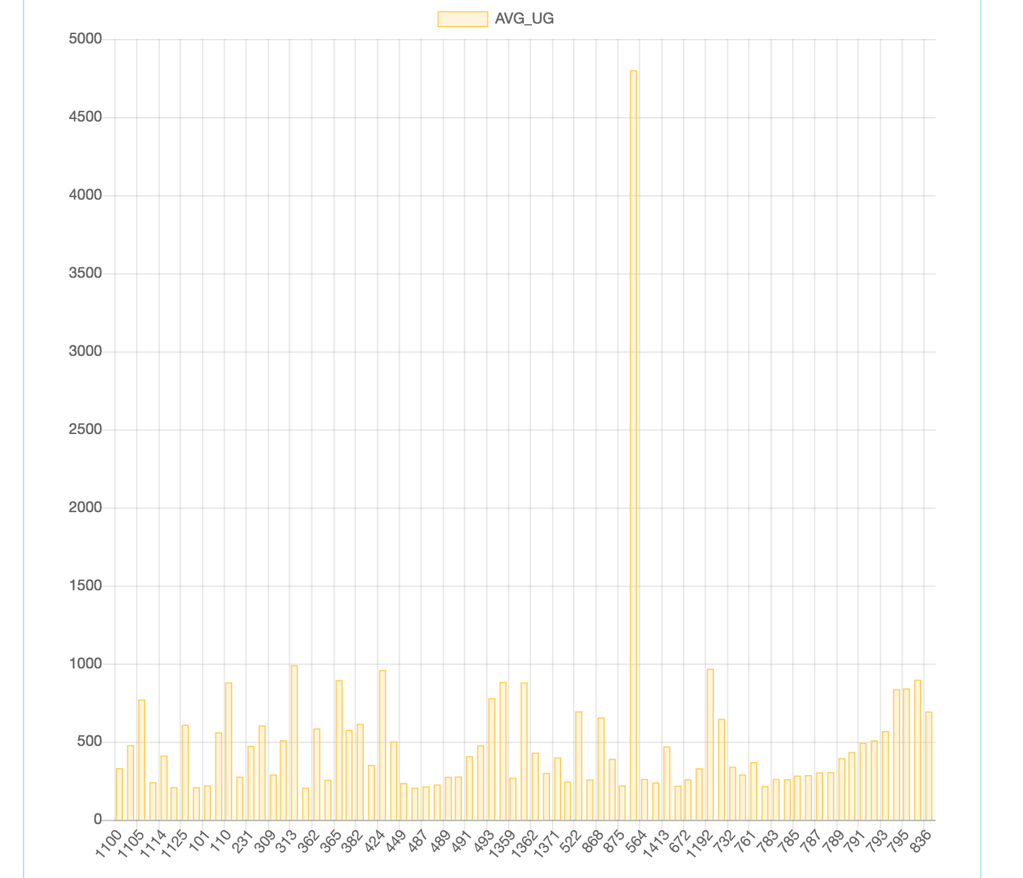

Plot the dataset in line chart

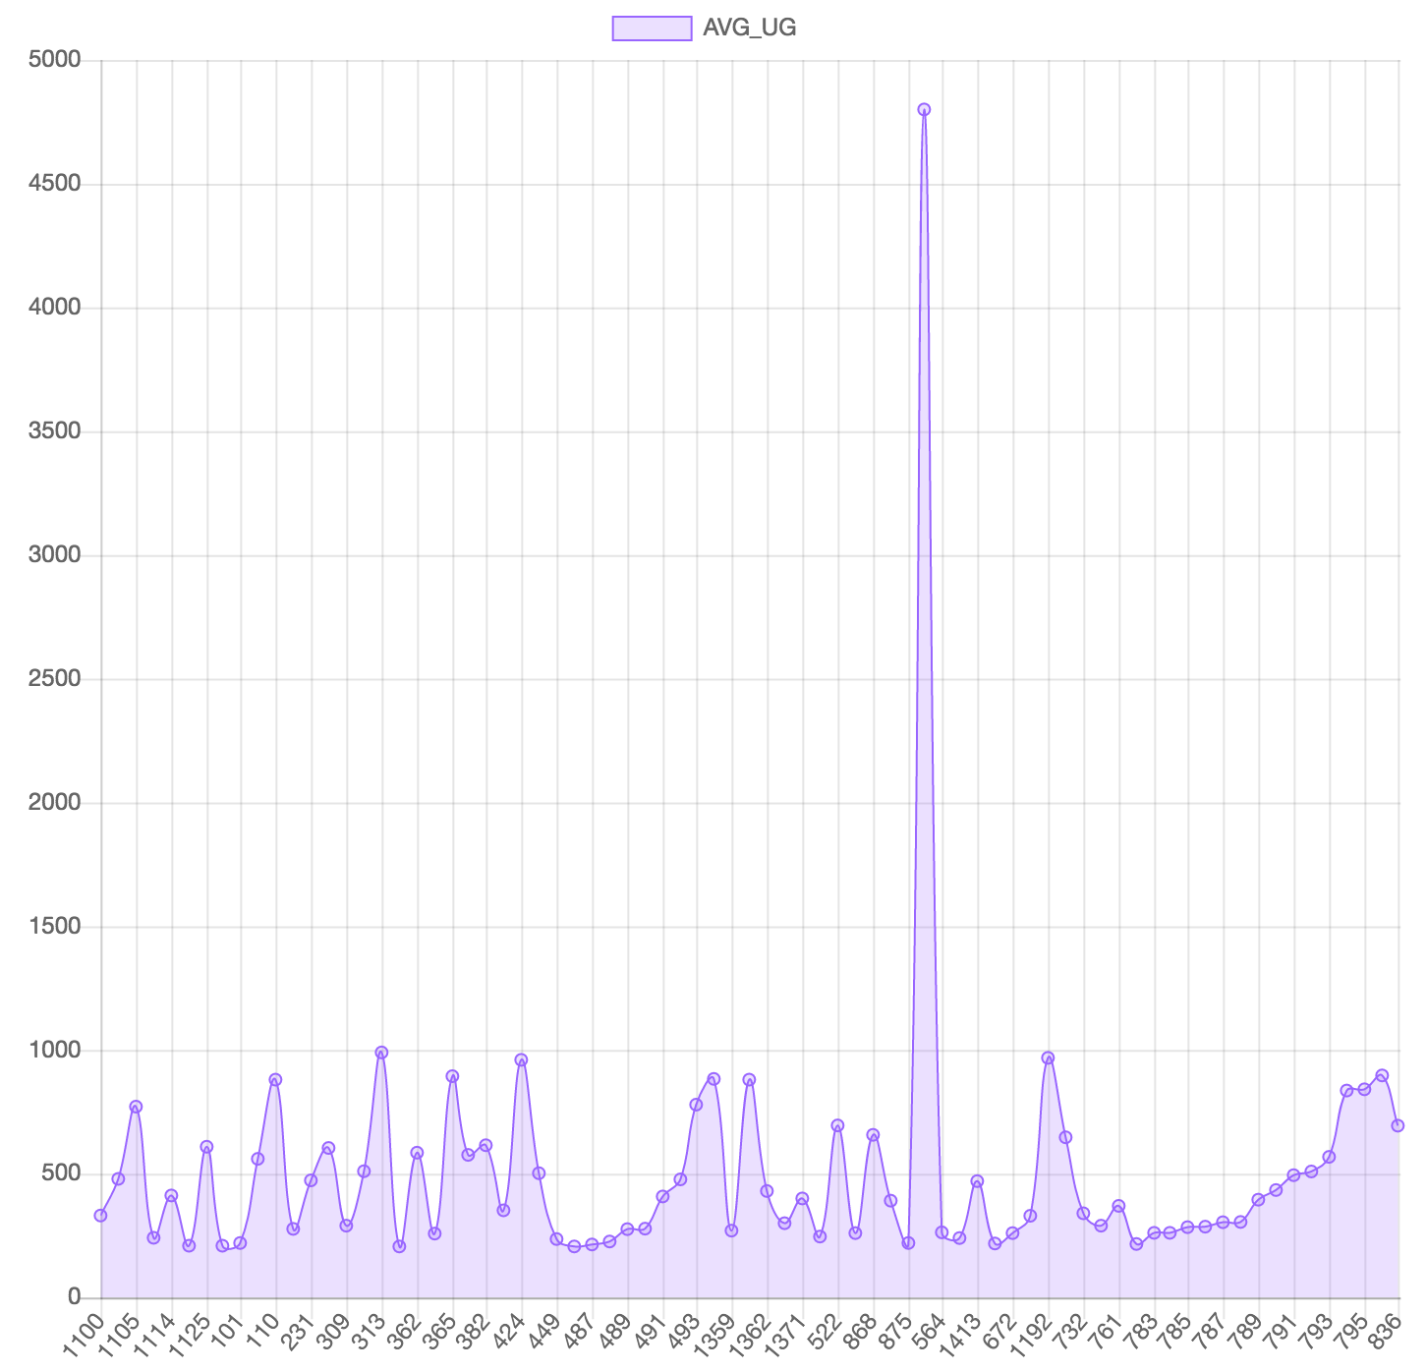

Plot the dataset in pie chart

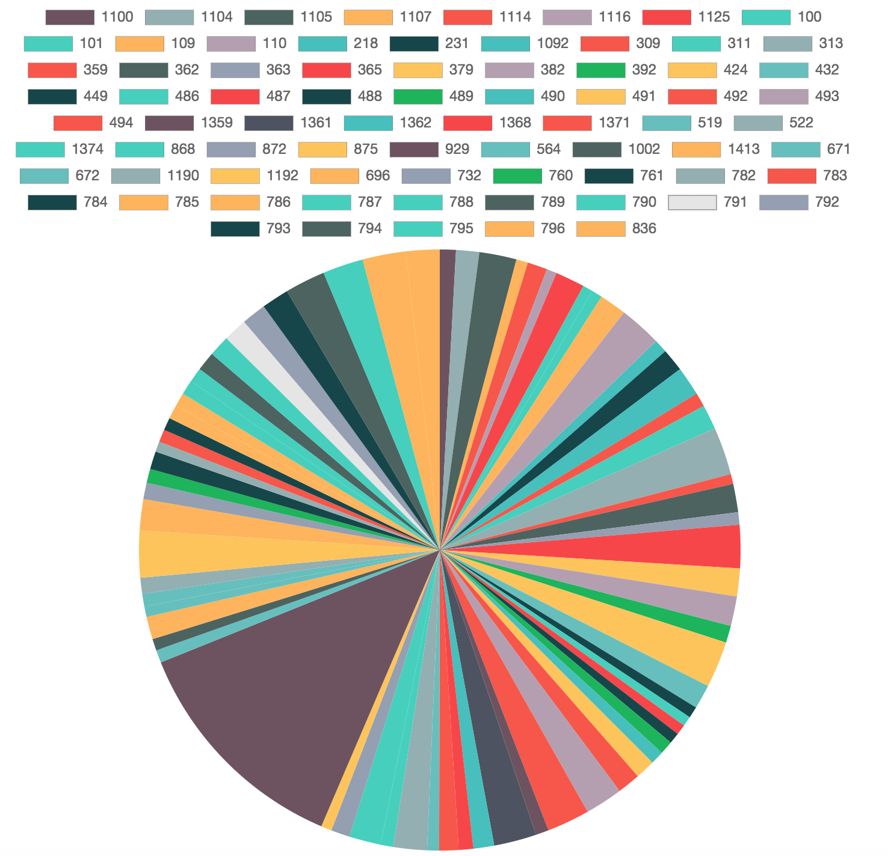

Plot the dataset in Doughnut chart

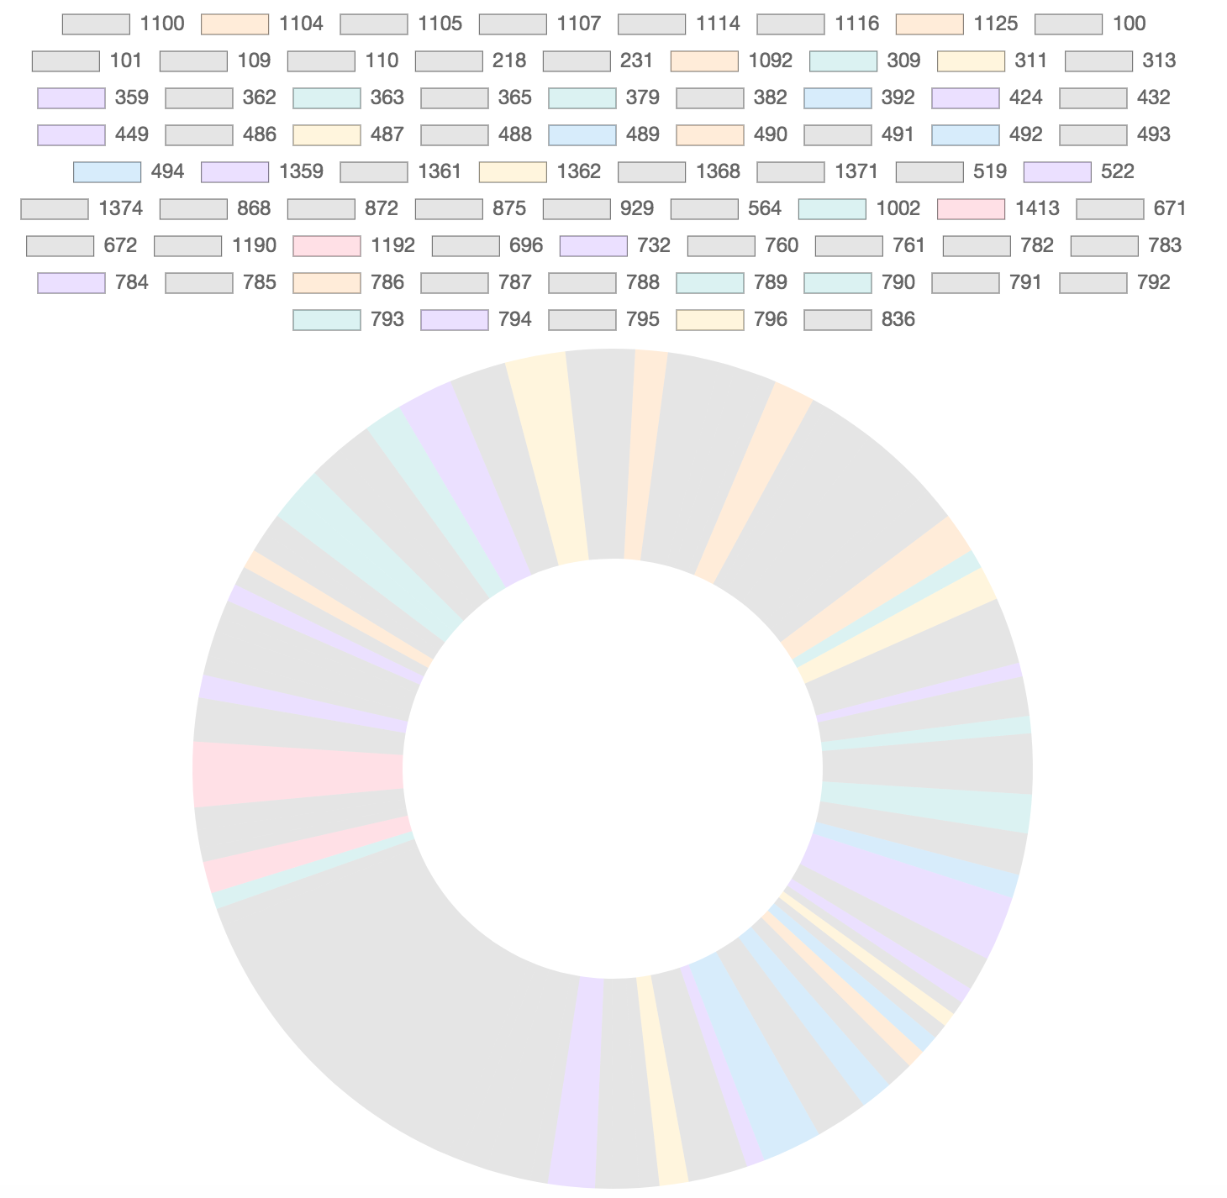

Plot the dataset in stacked bar chart

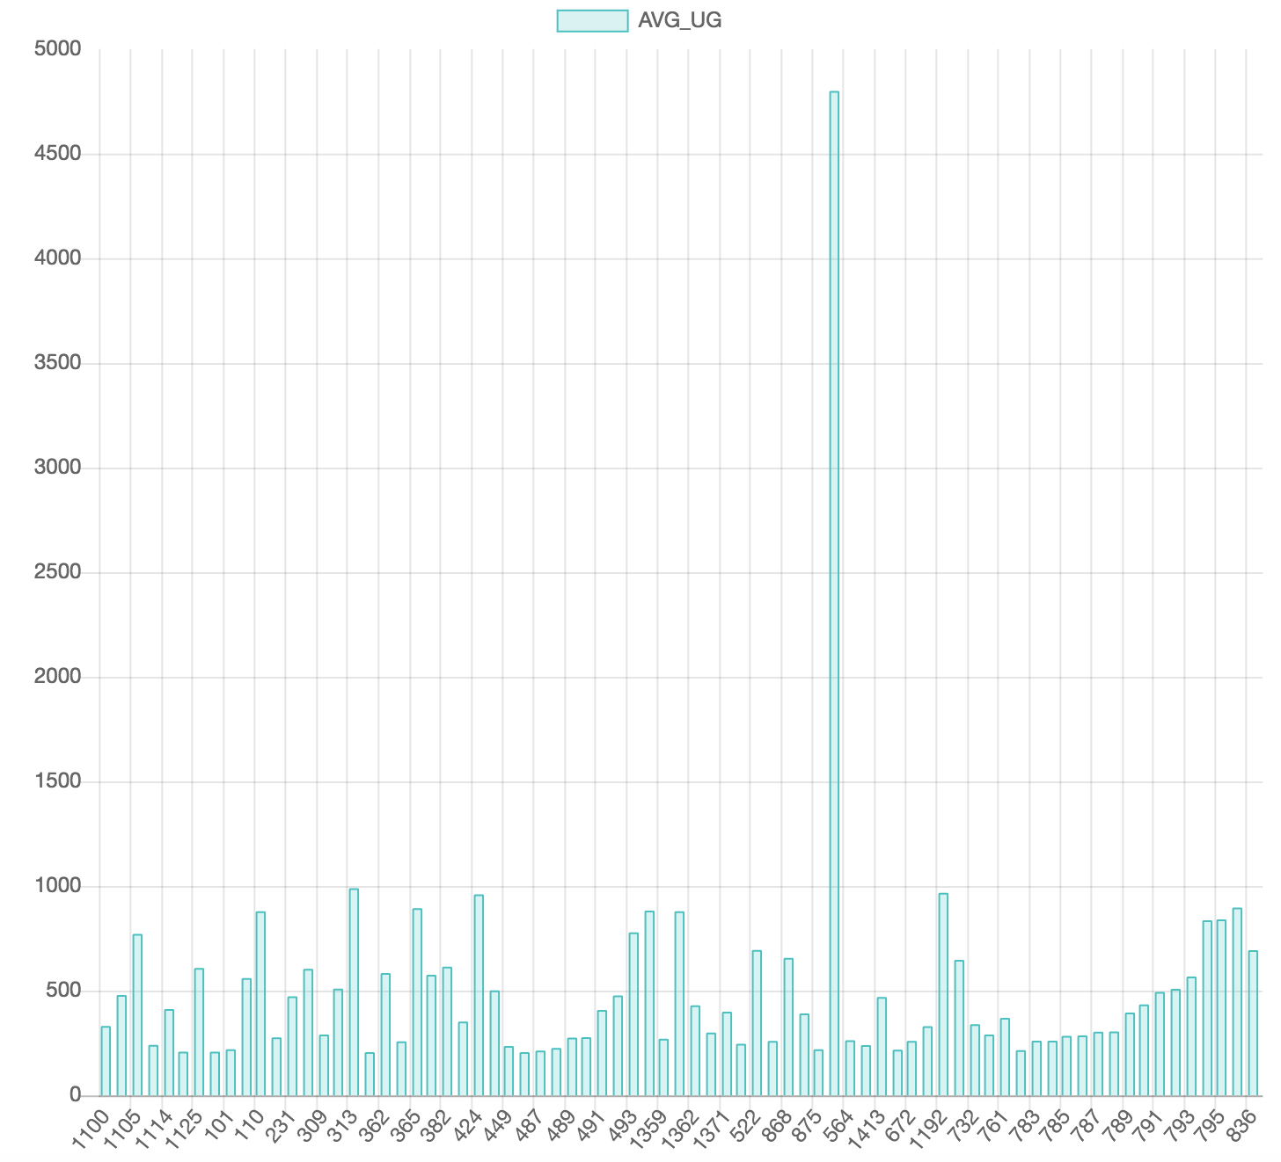

Plot the dataset in Heat Map 1

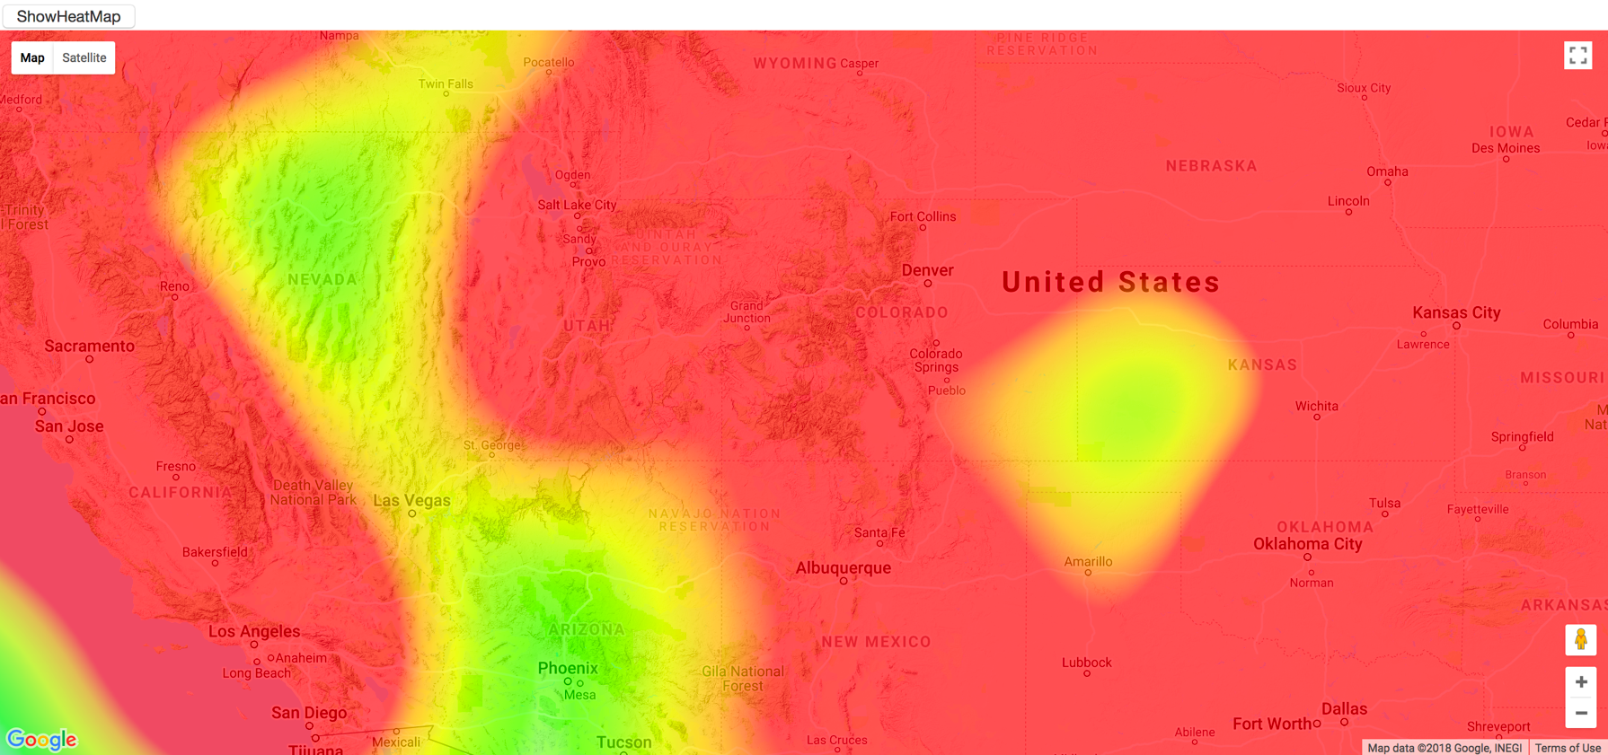

Plot the dataset in Heat Map 2

